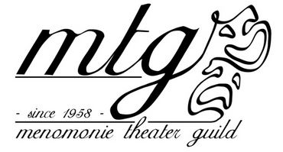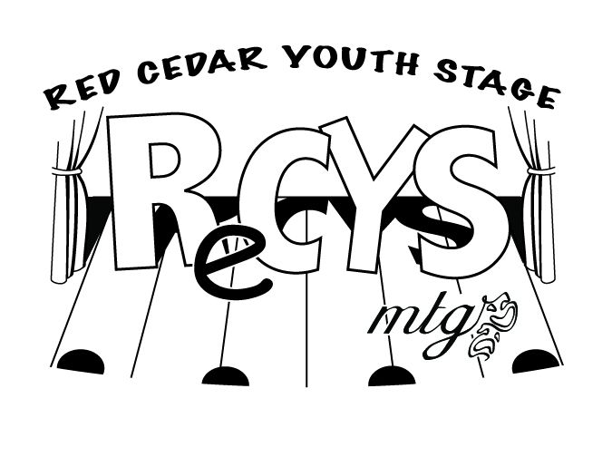

*RELEASE AND WAIVER OF LIABILITY for* ***VOLUNTEERS***

This Release and Waiver of Liability is executed this day of ____________ , 2014, by_________________________________ (the “Volunteer”) in favor of Menomonie Theater Guild, its directors, officers, employees, volunteers, and agents and the Menomonie Color Dash Organizing Team, its directors, officers, volunteers, and agents.

I, the Volunteer, hereby freely and voluntarily, without duress, execute this Release under the following terms:

1. **Waiver and Release**. I hereby release and forever discharge and hold harmless Menomonie Theater Guild/Menomonie Color Dash Organizing Team and its successors and assigns from any and all liability, claims, demands, and causes of action, of whatever kind of nature, either in law or equity, which may hereafter arise from my participation with Menomonie Theater Guild/Menomonie Color Dash Organizing Team and/or any project, activity, or event sponsored, managed, arranged, or promoted by, or otherwise affiliated or associated with Menomonie Theater Guild/Menomonie Color Dash Organizing Team.

I understand and acknowledge that this Release discharges Menomonie Theater Guild/Menomonie Color Dash Organizing Team from any liability or claim that I may have against Menomonie Theater Guild/Menomonie Color Dash Organizing Team with respect to any bodily or other injury, illness, death, or property damage that may result from my participation. I also understand that Menomonie Theater Guild/Menomonie Color Dash Organizing Team does not assume any responsibility or obligation to provide financial assistance or other assistance, including, but not limited to, medical, health, or disability insurance, in the event of injury, illness, death, or property damage.

2. **Insurance**. I understand that Menomonie Theater Guild/Menomonie Color Dash Organizing Team may elect to provide group accident or other liability insurance. Any coverage so provided will be governed by the policy language. Except to the extent that it may provide such insurance, Menomonie Theater Guild/Menomonie Color Dash Organizing Team does not carry or maintain any health, medical, disability, damage, or other liability insurance coverage for the benefit of its volunteers, and expressly disclaims any responsibility or obligation to do so. AS A VOLUNTEER, I AM EXPECTED AND ENCOURAGED BY Menomonie Theater Guild/Menomonie Color Dash Organizing Team TO MAINTAIN MEDICAL, HEALTH, AND ALL OTHER APPLICABLE INSURANCE COVERAGE FOR MY OWN BENEFIT.

3. **Medical Treatment**. Except as otherwise agreed to by Menomonie Theater Guild/Menomonie Color Dash Organizing Team in writing, I hereby release and forever discharge Menomonie Theater Guild/Menomonie Color Dash Organizing Team from any and all liability claims, demands, and causes of action whatsoever that may arise on account of any first aid or other medical treatment rendered during my participation with Menomonie Theater Guild/Menomonie Color Dash Organizing Team and/or any project, activity, or event sponsored, managed, arranged, or promoted by, or otherwise affiliated or associated with Menomonie Theater Guild/Menomonie Color Dash Organizing Team .

4. **Assumption of Risk**. I understand that my participation with Menomonie Theater Guild/Menomonie Color Dash Organizing Team and/or any project, activity, or event sponsored, managed, arranged, or promoted by, or otherwise affiliated or associated with Menomonie Theater Guild/Menomonie Color Dash Organizing Team may include activities that may be hazardous to me. I further recognize and understand that such participation may involve certain inherently dangerous activities. I hereby expressly and specifically assume the risk of injury or harm in the activities and release Menomonie Theater Guild/Menomonie Color Dash Organizing Team from all liability for injury, illness, death, and/or property damage that may result.

5. **Photography/Audio Release.** I do hereby grant and convey unto Menomonie Theater Guild/Menomonie Color Dash Organizing Team rights, titles, and interest in and to any and all photographic images and video or audio recordings made by or on behalf Menomonie Theater Guild/Menomonie Color Dash Organizing Team, or made with its consent, during my participation in the Color Dash and/or any project, activity or event sponsored, managed, arranged, or promoted by, or otherwise affiliated or associated with Menomonie Theater Guild/Menomonie Color Dash Organizing Team, including, but not limited to, any royalties, proceeds, or other benefits derived from such photographs or recordings.

6. **Other**. I expressly understand and agree that this Release is intended to be as broad and inclusive as permitted by law, and that this Release shall be governed by and interpreted in accordance with the laws of this state, county, city and/or township. I agree that in the event that any clause or provision of this Release shall be held to be invalid by any court of competent jurisdiction, the invalidity of such clause or provision shall not otherwise affect the remaining provisions of this Release.

I, for myself and my heirs, executors, administrators and assigns, hereby release, waive and discharge Menomonie Theater Guild/Menomonie Color Dash Organizing Team and its officers, directors, employees, agents and volunteers of and from any and all claims which I or my heirs, administrators and assigns ever may have against any of the above for, on account of, by reason of or arising in connection with such volunteer efforts or my participation therein, and hereby waive all such claims, demands and causes of action.

By signing below, I acknowledge that I have read and understand this Release, and agree to its provisions. I am at least 18 years of age or I am the parent or guardian of a participant who is less than 18 years of age.

_________________________________________ _________________________________________ ______________________

Printed Name of Volunteer Signature of Volunteer Date

_________________________________________ _________________________________________ ______________________

Printed Name of Volunteer Signature of Volunteer Date

*For Volunteers Under 18: (put add’l names/signatures on the back)*

_________________________________________ _________________________________________ ______________________

Printed Name of Volunteer Signature of Parent/Guardian Date